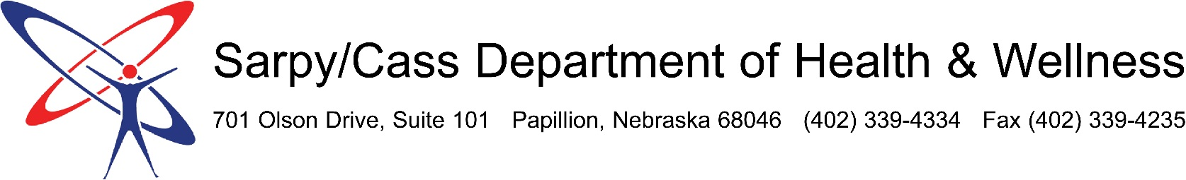

Strategic Plan 2016-2020

VISION
The highest quality of life for all Sarpy and Cass County residents

MISSION
To improve the lives of all Sarpy and Cass County residents through prevention, promotion, and protection of the public’s health

ORGANIZATIONAL VALUES
- Collaboration: We work together with our community partners to achieve common goals.
- Empowerment: We provide our community with education, resources, and support to make well-informed decisions.
- Excellence: We strive to provide the highest quality of services through individual efforts, teamwork, innovation, and accountability.
- Integrity: We are honest, open, and accountable for our actions.
- Respect: We treat all people with dignity by understanding, accepting, and valuing their differences.

STRATEGIC DIRECTION AND GOALS

Strategic Direction | Strategic Goals
Securing Departmental Sustainability | - Generate additional funding sources  - Grow Board of Health advocacy efforts
Expanding Internal Capacity | - Establish quality improvement procedures  - Develop staff capacity  - Identify and prioritize programs and services  - Expand our physical space
Strengthening Identity and Partnerships | - Cultivating community partnerships  - Market and communicate about the Department

