Countryside Public Health
Community Health Assessment Report

Countryside Public Health
201 13th St S
Benson, MN 56215
Questions:
Lauch@countryside.co.swift.mn.us
Shelly@countryside.co.swift.mn.us
Published April 2015
Contents
Introduction 1
About our Counties 1
Demographics 2
Aging Population 2
Population by Race 2
Population by Gender 3
Population Trends 4
Economic Status 5
Unemployment 5
Population Living in Poverty 5
Free and Reduced Lunch rate 5
Medical Assistance Enrollment 6
Home ownership 7
Education 7
High School Graduation Rate 7
Enrollment by Race/Ethnicity 8
Students enrolled in Special Education 9
Students with limited English Proficiency 9
Natality 10
Birth Rate 10
Number of Births 10
Preterm Births 11
Low Birth Weight 11
Prenatal Care in First trimester 12
Births to Unmarried Women 12
Teen pregnancy birth rate 13
Infant Deaths 13
Births by Race/Ethnicity 14
Morbidity and Mortality 15
Death Rate 15
Leading Causes of Death 16
Leading Causes of Death under age 75 17
Leading Cause of Death by Age group 17
Cancer incidence 19
Diabetes Prevalence 19
Morbidity rates 19
Health Behaviors 20
Smoking and Tobacco Use 20
Alcohol Use 21
Nutrition 22
Physical Activity 23
BMI in Adults 25
BMI in Students 26
Infectious Disease 28
Childhood Immunization Rates 28
TB 28
Sexually Transmitted Infections 29
Food-Borne Illness 30
Unintentional Injury 31
Death rates 31
Motor Vehicle Injuries 31
Mental Health 32
Suicide Rates 32
Access to Health Care 33
Doctors 33
Dentists 34
Violence 37
Bullying in Schools 37
Child Maltreatment 38
Out of Home Placement 38
Single Parent Households 38
Environmental Health 39
Radon 39
Elevated Blood Lead Levels 39
Age of Homes 40
References 42

Introduction

About our Counties
Big Stone County was founded in 1862 and is named for Big Stone Lake. Ortonville is the County Seat and also the largest City. Other cities in Big Stone County include Barry, Beardsley, Clinton, Correll, Graceville, Johnson and Odessa. The population density according to 2010 census was 11/sq mi. 5.5% of the total area is made up of water, the highest percentage in our five counties. The population according to 2010 census was 5,269 and the largest population recorded was back in 1940 with 10,447.¹
Chippewa County was formed in 1862, organized in 1868, and is named for the Chippewa Indians. Montevideo is County Seat and largest city. Other cities include Clara City, Granite Falls (partial), Maynard, Milan and Watson. The population density according to the 2010 census was 21/sq mi. Only 1.1% of the total area in the county is made up of water. The population according to the 2010 census puts Chippewa County at 12,441 residents. The largest population recorded was 16,927 back in 1940.²
Lac qui Parle County was founded in 1871. The French translation of Lac qui Parle is “the lake that speaks”. Madison is County seat and largest city. Other cities include Bellingham, Boyd, Dawson, Louisburg, Marietta, Nassau and Ortonville. The population density according to the 2010 census was 9.5/sq mi. 1.7% of the total area in the county is made up of water. The 2010 census records Lac qui Parle’s population at 7,259. The largest population recorded was back in 1920 with 15,554 residents.³
Swift County was founded in 1870 and is named for Henry Adoniram Swift, Minnesota’s governor in 1863. Benson is the County Seat and the largest city. Other cities include Appleton, Clontarf, Danvers, De Graff, Holloway, Kerkhoven and Murdock. The population density according to the 2010 census was 10/sq mi. 1.3 % of the total area in the county is made up of water. The 2010 Population was 9,783 and the largest population was back in 1950 at 15,837. ⁴
Yellow Medicine County was founded 1871 and is named for Yellow Medicine River. County names is based on a plant which the native Dakota people used the yellow root of for medicinal purposes. County seat is Granite Falls which is also the largest city. Other cities include Canby, Clarkfield, Echo, Hanley Falls, Hazel Run, Porter, St. Leo and Wood Lake. The Upper Sioux Indian Reservation is entirely within the county. The population density according to the 2010 census was 14.sq mi. 0.5%of the total area in the county is considered water, the lowest out of our five counties. The 2010 Census shows population at 10,438. The largest population was recorded in 1940 at 16,917. ⁵

Demographics

Aging Population
In 2011, the Countryside population of individuals aged 65 and over made up a larger percentage of our counties population, 20.9 percent, than that of the State of Minnesota, 13.1 percent. Our counties ranged anywhere from 19.3 percent to 25.3 percent, still well over the state of MN percentage.⁶
State/County/CHS | State of MN | Countryside | Big Stone | Chippewa | Lac qui Parle | Swift | Yellow Medicine
Percentage of Population over age 65 | 13.1 | 20.9 | 25.3 | 19.3 | 23.4 | 20.1 | 19.7

Population by Race
Our counties are primarily comprised of White individuals, making up 96.59% of our population. American Indian, Multi-racial, Asian, and African American make up the remaining 3.41% respectively. The state of MN, slightly more diverse, is still predominately White at 86.92%followed by African American, Asian, Multi-racial, and American Indian, respectively.

Population by Gender
Countryside has a higher percentage of 15-17 year olds (slightly higher 4.13 compared to 4.05) and 50 and older than the state of MN. Ages 50 and older makes up 43.36 % of our total population, the State of MN percentage for that same age group is 33.16%. The Working Class, ages 18 to 64 make up 56.71 % of the total population in Countryside. The State of MN Working Class population is at 62.97% of the total population. Countryside has a slightly lower percentage of school age kids than the state of MN at 16.38% and 17.31% respectively.⁶

Population Trends
Countryside Population has continually decreased from 2002-2010 with a slight increase in population in 2011. The State of MN has been steadily increasing with the exception of 2010 where the population decreased.⁶

Economic Status

Unemployment

The unemployment rate in Countryside has been lower than the state average since 2009; however the gap has been narrowing as the year’s progress. The unemployment rate peaked in 2009 and has been continually dropping since then.

Population Living in Poverty
State/CHB/County | Percent of people of all ages living at or below 200% of poverty
State of Minnesota | 26.1
Countryside | 31.0
Big Stone County | 35.8
Chippewa County | 29.6
Lac qui Parle County | 30.1
Swift County | 32.0
Yellow Medicine County | 30.2
Source: 2007-2011 American Community Survey (ACS), US Census
Countryside has a higher percentage of population living in poverty than the State of MN; all five of our counties reported a higher percentage of total population living in poverty than the State.⁶

Free and Reduced Lunch rate
Free and Reduced Lunch Eligibility for 2012-2013 School year
State/CHB/County | Percentage of Students Eligible for Free or Reduced Lunch
State of Minnesota | 38.3
Countryside | 40.70
Big Stone | 41.5
Chippewa | 41.2
Lac qui Parle | 43.0
Swift | 35.6
Yellow Medicine | 42.8
Countryside shows a higher percentage of students eligible for the free/reduced lunch program at 40.7 percent of students where the state shows 38.3 percent of students eligible for the program. Lac qui Parle County shows the highest percentage of students eligible for the program out of our five counties.⁸

Countryside has continually had a higher percentage of students eligible for the free and reduced meal program through the school. Countryside had 42.37% of students eligible for the free and reduced meals in the 2012-2013 school year where the State of MN had 38.30% of student’s eligible.⁹

Medical Assistance Enrollment
Percentage of Total Population Enrolled (average) in Minnesota Medical Assistance, 2011
State/CHB | All Families and children | Children 0-19 | MA Adults with No Kids | Elderly | Disabled | Total
State of Minnesota | 8.69 | 4.61 | 1.27 | 1.06 | 2.25 | 13.27
Countryside | 8.83 | 5.66 | 0.87 | 2.21 | 2.52 | 14.43
Countryside has a higher percentage of our total population enrolled in medical assistance than the state of MN, with our children aged 0 through 19 a full percentage point higher than the state.⁶

Home ownership

There has been a slight decrease in the percentage of housing occupied by owner between 2010 and 2011. We have a higher percentage of housing occupied by the owner than the state.⁶

Education

High School Graduation Rate

Countryside has maintained a higher graduation rate than the state of MN. Countryside’s highest graduation rate was seen during the 2010-2011 school year with 87.5 per 100 students graduating. The graduation rate has been slowly increasing in the state of MN from 75.8 in 2009-2010 to 78.4 in 2012-2013. Countryside had a dip in our graduation rate during the 2011-2012 school year but did rise again in the 2012-2013 school year. ⁶

Enrollment by Race/Ethnicity

The race seen in our schools is predominately white, following our population demographics. Our percentage of American Indian students is higher than the state of MN where as the remaining races are below state percentages.⁶

Students enrolled in Special Education

Countryside sees a higher percentage of students in our special education departments than the state of MN. Our area appears to be trending upward with then number of students seen in our special education programs.⁶

Students with limited English Proficiency

Our student population with Limited English proficiency is well below the state percentage. The percentage of students with limited English proficiency has been slightly increasing over the years in both Countryside and the State of MN.⁶

Natality

Birth Rate

Countryside’s birth rates as been slightly increasing since 1998. Countryside birth rate continues to be lower than state of MN.⁹

Number of Births

Preterm Births

The percentage of premature singleton births (less than 37 weeks gestation) has been increasing since 1993. Countryside has had a lower percentage of premature births than the state.⁹

Low Birth Weight

Our percentage of low birth weight babies had been trending upward from 1993 through 2007 with a decrease happening in 2008-2012. The state’s percentage of low birth weight babies has also been trending upward with a slight drop in 2008-2012.⁹

Prenatal Care in First trimester

With the exception of the 1998-2002 time frame, Countryside has had a higher percentage of women receiving prenatal care in the 1st trimester than the state of MN. The percentage of women receiving prenatal care within the 1st trimester has been increasing since 1998.⁹

Births to Unmarried Women

The percentage of births to unmarried mothers has been increasing in both Countryside and the State of MN. Countryside has a higher percentage of births to unmarried mothers than the state since 1998.⁹

Teen pregnancy birth rate

The teen birth rate in our area shows a higher rate than the state of MN in 2008-2012cohort. Our teen pregnancy increased from the 2003-2007cohort to the 2008-2012 cohort.⁹

Infant Deaths

Countryside had a lower percentage of Infant deaths than the state of MN since 1998. There was a slight increase in percentage from the 2003-2007cohort to the 2008-2012 cohort for both Countryside and the State of MN.⁹

Births by Race/Ethnicity

Countryside has a higher percentage of births born to white mothers than the state of MN. Our percentage of births to Hispanic mothers is also larger than the state.⁶

Morbidity and Mortality

Death Rate

Our overall age adjusted death rate has been lower than the state of MN. ⁹

Our age adjusted death rate for females in Countryside is lower than the age adjusted death rate for males. Our male age adjusted death rate as been decreasing over the years. ⁹

Leading Causes of Death
 | State of MN, 2011 |  | Countryside, 2011
 | All Ages |  | All Ages
Cause | Rank | Number | Rank | Number
Alzheimer's Disease | 6 | 1,449 | 7 | 17
Cancer | 1 | 9,468 | 2 | 129
Cirrhosis | 13 | 436 | 12 | 4
Chronic lower respiratory dis. | 4 | 2,174 | 3 | 38
Diabetes | 7 | 1,179 | 8 | 15
Heart Disease | 2 | 7,234 | 1 | 140
Hypertension | 11 | 489 | 12 | 4
Nephritis | 8 | 708 | 9 | 11
Parkinson’s | 12 | 475 | 10 | 8
Pneumonia and Influenza | 10 | 669 | 6 | 20
Pneumonitis due to solids/liquids | 15 | 321 | 11 | 5
Septicemia | 14 | 338 | 12 | 4
Stroke | 5 | 2,145 | 4 | 35
Suicide | 9 | 684 | 15 | 3
Unintentional Injury | 3 | 2,309 | 5 | 30

Leading Causes of Death under age 75
 | State of Minnesota, 2011 |  |  | Countryside, 2011
 | Premature Deaths |  |  | Premature Deaths
Cause | Rank | Number | Rate | Rank | Number | Rate
Cancer | 1 | 24,505 | 91.9 | 1 | 255 | 93.5
Cirrhosis | 8 | 1,676 | 6.1 | * | 18 | *
Chronic Lower Respiratory Disease | 4 | 3,099 | 12.0 | 5 | 28 | 9.9
Diabetes | 7 | 2,172 | 8.2 | * | 14 | *
Heart Disease | 2 | 10,403 | 39.0 | 2 | 134 | 49.2
Nephritis | 9 | 896 | 3.4 | * | 9 | *
Pneumonia and Influenza | 10 | 624 | 2.4 | * | 4 | *
Stroke | 6 | 2,250 | 8.6 | 4 | 28 | 9.9
Suicide | 5 | 2,831 | 11.1 | * | 16 | *
Unintentional Injury | 3 | 6,167 | 24.2 | 3 | 74 | 36.4
* Rate and rank not calculated for fewer than 20 deaths
Rate calculated off deaths to residents under age 75 per 100,000 persons under age 75, age adjusted to 2000 US Standard Population⁶

- Cancer remains to be the leading cause of death for all ages and for those under age 75 for the State of MN. Cancer unseats Heart Disease as the leading cause of death for those under age 75 in our area. Unintentional injury also jumps up the ranks to 3rd as a leading cause of death under age 75.
- Countryside has a higher death rate in Cancer, Heart Disease, Unintentional Injury, and Stroke than the State in premature deaths.

Leading Cause of Death by Age group
Countryside, 2011⁶
 | All Ages |  |  | Age Group
Cause | Rank | Number |  | 0-4 | 5-14 | 15-24 | 25-44 | 45-54 | 55-64 | 65-74 | 75+
Alzheimer's Disease | 7 | 17 |  | 0 | 0 | 0 | 0 | 0 | 1 | 1 | 15
Cancer | 2 | 129 |  | 0 | 0 | 0 | 4 | 7 | 13 | 21 | 84
Cirrhosis | 12 | 4 |  | 0 | 0 | 0 | 0 | 0 | 1 | 0 | 3
Chronic lower respiratory dis. | 3 | 38 |  | 0 | 0 | 0 | 0 | 0 | 0 | 9 | 29
Diabetes | 8 | 15 |  | 0 | 0 | 0 | 0 | 1 | 0 | 1 | 13
Heart Disease | 1 | 140 |  | 0 | 0 | 0 | 0 | 1 | 22 | 16 | 101
Hypertension | 12 | 4 |  | 0 | 0 | 0 | 0 | 0 | 0 | 0 | 4
Nephritis | 9 | 11 |  | 0 | 0 | 0 | 0 | 0 | 0 | 1 | 10
Parkinson’s | 10 | 8 |  | 0 | 0 | 0 | 0 | 0 | 0 | 0 | 8
Pneumonia and Influenza | 6 | 20 |  | 0 | 0 | 0 | 0 | 0 | 0 | 0 | 20
Pneumonitis due to solids/liquids | 11 | 5 |  | 1 | 0 | 0 | 0 | 0 | 0 | 0 | 4
Septicemia | 12 | 4 |  | 0 | 0 | 0 | 0 | 0 | 0 | 1 | 3
Stroke | 4 | 35 |  | 0 | 0 | 0 | 0 | 2 | 1 | 3 | 29
Suicide | 15 | 3 |  | 0 | 0 | 0 | 3 | 0 | 0 | 0 | 0
Unintentional Injury | 5 | 30 |  | 0 | 0 | 5 | 7 | 2 | 1 | 3 | 12
Total |  | 463 |  | 1 | 0 | 5 | 14 | 13 | 39 | 56 | 335

State of MN, 2011⁶
 | All Ages |  |  | Age Group
Cause | Rank | Number |  | 0-4 | 5-14 | 15-24 | 25-44 | 45-54 | 55-64 | 65-74 | 75+
Alzheimer's Disease | 6 | 1,449 |  | 0 | 0 | 0 | 0 | 4 | 12 | 61 | 1,372
Cancer | 2 | 9,468 |  | 11 | 11 | 23 | 223 | 766 | 1,684 | 2,256 | 4,494
Cirrhosis | 14 | 436 |  | 1 | 0 | 0 | 37 | 110 | 137 | 79 | 72
Chronic lower respiratory dis. | 5 | 2,174 |  | 2 | 0 | 2 | 12 | 44 | 162 | 454 | 1,498
Diabetes | 8 | 1,179 |  | 0 | 0 | 1 | 30 | 67 | 153 | 189 | 739
Heart Disease | 3 | 7,234 |  | 8 | 3 | 12 | 127 | 374 | 693 | 886 | 5,131
Hypertension | 12 | 489 |  | 0 | 0 | 0 | 4 | 14 | 40 | 65 | 366
Nephritis | 9 | 708 |  | 1 | 0 | 0 | 7 | 19 | 42 | 97 | 542
Parkinson’s | 13 | 475 |  | 0 | 0 | 0 | 0 | 2 | 9 | 40 | 424
Pneumonia and Influenza | 11 | 669 |  | 8 | 3 | 8 | 8 | 20 | 45 | 57 | 520
Pneumonitis due to solids/liquids | 16 | 321 |  | 3 | 0 | 0 | 3 | 8 | 27 | 35 | 245
Septicemia | 15 | 338 |  | 5 | 2 | 2 | 9 | 18 | 45 | 47 | 210
Stroke | 6 | 2,145 |  | 4 | 0 | 0 | 20 | 67 | 134 | 246 | 1,674
Suicide | 10 | 684 |  | 0 | 12 | 89 | 224 | 139 | 123 | 56 | 41
Unintentional Injury | 4 | 2,309 |  | 30 | 25 | 165 | 377 | 320 | 257 | 197 | 938
Total |  | 30,078 |  | 73 | 56 | 302 | 1,081 | 1,972 | 3,563 | 4,765 | 18,266

- Percentage of deaths by age group⁶
  - Match state in 0-4
  - Less than state in 5-14,25-44,45-54,55-64,65-74
  - Higher than state in 15-24 and 75+

Cancer incidence
Age-adjusted rates per 100,000, 2005-2009⁶
State/County/CHB | Five-Year Total Population | New Cancers |  | 95% Confidence Interval
 |  | Number | Rate¹
Minnesota | 25,942,893 | 127,904 | 474.6 | 472.0 - 477.3
Big Stone | 26,674 | 196 | 449.1 | 382.2 - 526.0
Chippewa | 62,269 | 426 | 500.7 | 452.4 - 553.2
Lac Qui Parle | 36,289 | 272 | 457.4 | 400.7 - 521.4
Swift | 54,452 | 373 | 517.4 | 464.3 - 575.3
Yellow Medicine | 50,335 | 339 | 454.8 | 405.8 - 508.7
Big Stone, Chippewa, Lac Qui Parle, Swift and Yellow Medicine | 230,019 | 1,606 | 481.1 | 456.7 - 506.5

Countryside shows a higher rate of cancer than the state.

Diabetes Prevalence
Diabetes Prevalence among Adults Age >= 20 years, Minnesota 2009 based off 90 Percent Confidence Interval (CI) ⁶
State/County/CHB | Percent | Lower CI | Upper CI
State of MN | 6.4 | 5.7 | 7.1
Big Stone | 9.3 | 6.7 | 12.6
Chippewa | 9.1 | 6.7 | 12.1
Lac qui Parle | 10.5 | 7.7 | 13.9
Swift | 9.4 | 7.3 | 11.9
Yellow Medicine | 9.0 | 6.6 | 11.8

All of our counties show a higher percentage of diabetes in our 20 and older adult population.

Morbidity rates
Southwest South Central Adult health Survey, 2010¹⁰
Countryside Overall
Risk | Countryside | 19-County Region
Hypertension | 37.4 | 30.4
Diabetes | 10.6 | 8.1
Pre-Diabetes | 8.9 | 8.6
High Blood Cholesterol | 31.8 | 30.0
Heart Attack | 5.6 | 4.3
Angina/Coronary Heart Disease | 6.0 | 5.2
Stroke | 3.1 | 2.8
Asthma | 11.5 | 11.3

19-County Region consists of Big Stone, Blue Earth, Brown, Chippewa, Cottonwood, Jackson, Kandiyohi, Lac qui Parle, Le Sueur, Lincoln, Lyon, Murray, Nicollet, Pipestone, Redwood, Renville, Swift, Waseca, and Yellow Medicine Counties. Countryside shows a higher percentage of all health conditions than the 19-County Region, with our highest percentages seen in Hypertension and High Blood Cholesterol. 10.6% of the population reported having diabetes where only 8.1% of the population in the 19-County Region reported having the disease.

Health Behaviors

Smoking and Tobacco Use

Tobacco use in 9th and 12th graders has been decreasing in both Countryside and the State of MN. Countryside continues to have a higher percentage of students using tobacco than the state.¹¹
Tobacco use in our adult population during the 2010 SW/SC Adult Health survey shows that 55% of our adult population has never smoked, 18% are current smokers leaving 27% as former smokers. 11% of the population has used some other tobacco product. We have a higher percentage of smokers in our male population, 46.5% have never smoked, than our female population where 63% have never smoked. We have a higher percentage of current smokers in our CHB than the 19-county region, 18.1 and 15.1 percent, respectively.¹⁰

We have consistently had a higher percentage of women smoke prenatally than the state of MN. Our smoking rates have continued to increase. The state of MN smoking percentage in pregnant women had been decreasing with a slight increase from 2008-2012.⁹

Alcohol Use

The percentage of high school seniors that have reported alcohol use in the last month has been consistently higher than the state. The percentage of students using alcohol has been decreasing since 2004 for Countryside and as been decreasing since 1998 for the State of MN.¹¹

Nutrition
Total servings of fruit and vegetables – SW/SC Adult Health Survey
Overall
CHB/Region | 0 servings | 1-2 servings | 3-4 servings | 5 or more
Countryside CHB | 6.2 | 31.0 | 35.6 | 27.2
19-County region | 6.4 | 28.4 | 34.4 | 30.8
Countryside has fewer adults getting the recommended 5 or more fruits and vegetables than 19-County Region. However, Countryside does have a slightly higher percentage of the population eating 1 or more servings of fruits and vegetables than the region. ¹⁰

Fewer than 1 in 5 students meet the recommended servings of fruits or vegetables in both Countryside and the state of MN. Countryside 9th Grade students have been consistently lower than the state in eating the recommended five or more servings of fruits or vegetables. The number of 9th graders meeting the recommendation decreased from 2007 to 2010. The 12th Grade students in Countryside have also been below the state on meeting the recommended servings of fruits or vegetables with the exception in 2001 where we were higher than the state. The percentage of 12th grade students meeting the recommendation has been increasing since 2004. ¹¹

Physical Activity
2010 SW/SC Adult Health Survey – Vigorous Activity (20 or more minutes per day and 3 or more days per week) ¹⁰
Overall
 | Meets recommendations | Insufficient activity | No Activity
Countryside CHB | 25.9 | 23.8 | 50.2
19-county region | 29.7 | 24.1 | 46.2
Females | 22.7 | 23.3 | 54
Males | 29.1 | 24.4 | 46.5

By Education Level
Education Level | Meets | Insufficient | None
Less than High School | 18.9 | 16.3 | 64.8
High School diploma or GED | 26.0 | 21.5 | 52.4
Some college, trade school, or associate’s degree | 25.7 | 22.5 | 51.8
Bachelor’s degree or higher | 28 | 30.9 | 41.1
We had an increase in the percentage of individuals who met the vigorous activity recommendations has their education level increased.¹⁰

Countryside has a lower percentage of 6th and 12th grade student’s meeting the vigorous activity recommendations than the state of MN. Countryside’s 9th graders have a slightly higher percentage of students meeting the vigorous activity guidelines than the state of MN.¹¹
Moderate Activity (30 or more minutes per day and five or more days per week) ¹⁰
Overall
 | Meets | Insufficient | None
Countryside-CHB | 38.9 | 45.3 | 15.8
19-County Region | 41.0 | 46.2 | 12.8

By Education Level
Education Level | Meets | Insufficient | None
Less than high school | 32.5 | 34.2 | 33.3
High school diploma or GED | 37.9 | 43.4 | 18.7
Some college, trade school, or associate’s degree | 38.5 | 45.9 | 15.6
Bachelor’s degree or higher | 42.8 | 50.2 | 7.1

We have a higher percentage of 9th and 12th grade students’ meeting the moderate activity guidelines than the state of MN. Fewer than 50 percent of our 6th grade students are meeting the moderate activity guidelines.¹¹
Barriers to Physical Activity – How much of a problem are the following factors for you in terms of preventing you from being more physically active? Percentage that answered “A big problem”
Factor | Countryside | 19-County Region
Lack of Time | 22.2 | 23.4
Lack of Programs | 14.9 | 8.6
No one to exercise with | 13.3 | 12.0
Cost of Fitness programs, gym memberships, or admission fees | 34.2 | 33.6
Public facilities are not open or available at the times I want to use them | 17.1 | 12.7
Long-term illness, injury, or disability | 12.4 | 10.3
Distance I have to travel to a place where I can be physically active | 13.5 | 8.3
No safe place to exercise | 2.9 | 1.9
Lack of self-discipline or willpower | 32.2 | 30.3
Other | 9.0 | 8.2

The largest barrier that prevents individuals from being more physically active was the cost of fitness programs, gym memberships, or admission fees in both Countryside and the 19-County Region. Lack of self-discipline or willpower followed right behind with 32.2% of Countryside’s population identifying it as a big problem. ¹⁰

BMI in Adults
2010 SW/SC Adult Health Survey¹⁰
Overall
CHB/Region | Not Overweight | Overweight but not obese | Obese
Countryside CHB | 27.7 | 35.4 | 36.9
19 County Region | 33.7 | 35.7 | 30.5
Countryside showed a higher percentage of obese individuals at 36.9% than the 19-County Region at 30.5%. Over two-thirds of the population in Countryside is considered overweight or obese.
By Household Income
Household Income | Not overweight | Overweight but not Obese | Obese
Less than $15,000 | 33.1 | 33.4 | 33.4
$15,000 to $35,000 | 24.2 | 36.3 | 39.6
$35,001 to $65,000 | 24.5 | 33.5 | 42.1
More than $65,000 | 30.9 | 36.9 | 32.1

Countryside’s households with less than $15,000 income had the highest percentage of individuals that were not overweight followed by the more than $65,000 income households. The two income groups flipped in the obese category with the more than $65,000 income household having the lowest percentage of obese individuals followed by the less than $15,000 income households.

BMI in Students

Countryside has had a higher percentage of 9th Grade students that are overweight but not obese than the state of MN. The percentage of 9th graders that are overweight increased from 2007 to 2010. The 12th grade students have stayed relatively similar from 2007 to 2010. ¹¹

Countryside has a higher percentage of 9th grade students who are obese than the state of MN. The Obesity percentage in the 9th graders increased from 2007 to 2010. Countryside has a lower percentage of 12th grade students who are obese than the state of MN. Obesity percentage in the 12th graders decreased from 2007 to 2010. ¹¹

Infectious Disease

Childhood Immunization Rates

We have a higher percentage of children up to date with their required vaccinations by age 2 than the state.⁶

TB
Countryside reported 4 Active TB cases from 2006-2012. The state of MN had 1,261 cases reported during that same time frame.

Sexually Transmitted Infections

The number of reported Sexually Transmitted Infection’s (STI’s) has been increasing since 2009 in the State of MN. Countryside STI cases had been decreasing from 2008 to 2010 with an increase from 2010 to 2011. ⁶

Food-Borne Illness

Campylobacteriosis is the highest reported case in both Countryside and the State of MN followed by Salmonellosis and Shigellosis. The reported case of Campylobacteriosis has been increasing since 2010 in Countryside.⁶

Unintentional Injury

Death rates

Countryside shows a higher age adjusted death rate in Unintentional Injury than the State of MN. Countryside’s rate has been steadily increasing since 1993. ⁹

Motor Vehicle Injuries

- We have a higher percentage of injuries that are severe and moderate
- We have a higher percentage of individuals killed due to MV injuries than the State

Mental Health

Suicide Rates

Countryside shows a lower percentage of 6th and 12th grade students who have had suicidal thoughts than the state of MN. Countryside showed a higher percentage of 9th grade students with suicidal thoughts in 2001, 2004 and 2007 than the state of MN. The percentage of 9th grade students with suicidal thoughts was below the state percentage in 2010. Countryside has been showing a decrease of suicidal thoughts in our 6th, 9th and 12th grade students since 2004.

Access to Health Care

Doctors
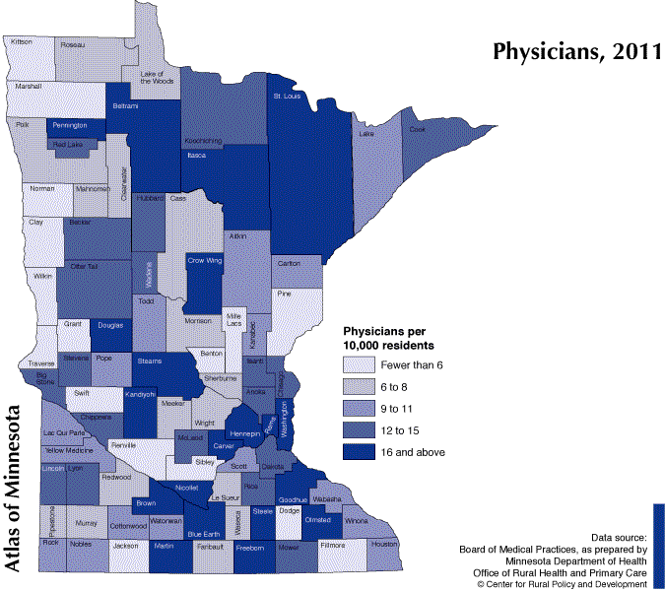
Swift County shows a need for physicians with showing fewer than 6 per 10,000 residents. Our remaining counties are slightly higher with 9 to 11 physicians per 10,000 in Lac qui Parle and Yellow Medicine Counties and 12 to 15 physicians in Big Stone and Chippewa Counties.¹²

Dentists
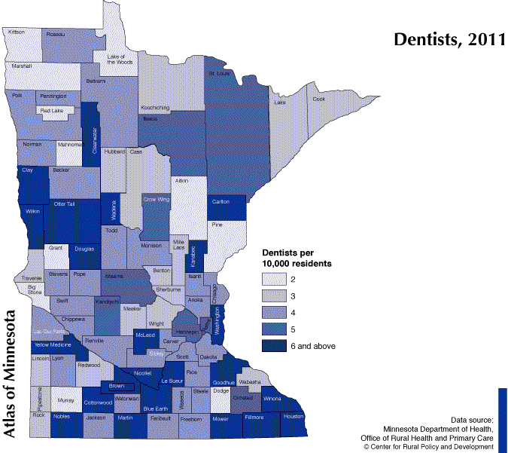
Big Stone County shows a lack of dentists for the population with only 2 per 10,000 residents. Chippewa, Lac qui Parle, and Swift Counties are showing 4 dentists per 10,000 residents. Yellow Medicine shows the greatest number of dentists per 10,000 residents with 6 and above.¹³
MA/MN Care oral health Service Use
Percentage of MA/MNCare Enrollees that received dental services.¹⁴
State/CHB/County | Claim Year | Age | Program Group | Total Enrollees | Enrollees Served | Percent Enrollees Served
Big Stone | 2012 | 0-5 | All Programs | 93 | 45 | 48.4
Chippewa | 2012 | 0-5 | All Programs | 262 | 76 | 29.0
Lac qui Parle | 2012 | 0-5 | All Programs | 93 | 26 | 28.0
Swift | 2012 | 0-5 | All Programs | 187 | 64 | 34.2
Yellow Medicine | 2012 | 0-5 | All Programs | 151 | 39 | 25.8
Countryside | 2012 | 0-5 | All Programs | 786 | 250 | 31.8
State of Minnesota | 2012 | 0-5 | All Programs | 93849 | 33700 | 35.9
Big Stone | 2012 | 6-20 | All Programs | 203 | 132 | 65
Chippewa | 2012 | 6-20 | All Programs | 492 | 270 | 54.9
Lac qui Parle | 2012 | 6-20 | All Programs | 277 | 151 | 54.5
Swift | 2012 | 6-20 | All Programs | 409 | 203 | 49.6
Yellow Medicine | 2012 | 6-20 | All Programs | 384 | 217 | 56.5
Countryside | 2012 | 6-20 | All Programs | 1765 | 973 | 55.1
State of MN | 2012 | 6-20 | All Programs | 202710 | 113403 | 55.9
Countryside’s 0-20 population enrolled in MA/MNCare that received dental services has been lower than the state. Under one-third of the individuals, ages 0-5, enrolled in either MA or MNCare have received some sort of oral health service. Big Stone County, at 48.4% for the 0-5 age group, has a higher percentage of enrollees receiving dental care than the state.

Violence

Bullying in Schools

Countryside’s 6th grade students showed a lower percentage of “bullies” than the State from 1998 to 2007. In 2010 the percentage of 6th grade bullies increased from 2007 and was also higher than the state. Countryside’s 9th grade bullies peaked in 2004 and decreased in both 2007 and 2010. The student’s in 12th grade show a lower percentage of bullies than the 6th and 9th grade students. Countryside’s percentage of 12th grade bullies has been decreasing since 2004.

Child Maltreatment
2011 Child Subjects of Maltreatment Reports per 1,000 in the Child Population (0-17 years old) ⁶
 | Total Rate | Family Assessment Rate | Investigation – Alleged Rate | Investigation – Determined Rate
State of Minnesota | 17.7 | 12.4 | 5.8 | 3.5
Countryside CHB | 22.0 | 16.0 | 6.2 | 4.5

A higher rate of child maltreatment is seen in Countryside than State of MN.

Out of Home Placement
Children in Out-of-home Care per 1,000 in the Child Population (0-17 years old), 2011⁶
- State of Minnesota – 8.9 per 1,000
- Countryside CHB – 9.5 per 1,000
Countryside has a higher rate of out of home placement than the state of MN.

Single Parent Households
Percent of children under 18 living in single parent headed households, 2012⁶
State/County/CHB | Percent of children under 18 living in single parent headed households
State of MN | 24.9
Countryside CHB | 24.6
Big Stone | 23.0
Chippewa | 32.0
Lac qui Parle | 19.5
Swift | 19.1
Yellow Medicine | 24.7

Countryside has a slightly lower percentage of children under 18 living in single parent headed households. We do however; have one county that is considerable higher than the state.

Environmental Health

Radon
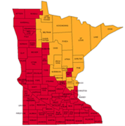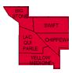
United State Environmental Protection Agency¹⁵
Countryside counties are all considered Zone 1 where the predicted average indoor radon screening level is greater than 4 pCi/L.

Elevated Blood Lead Levels

Countryside shows a higher percentage or Elevated Blood Lead Levels in the 2005, 2007, 2008 and 2009 birth years.

Age of Homes
Percentage of housing built before 1940 ¹⁷
- Big Stone – 37.8
- Chippewa – 33.8
- Lac qui Parle – 49.0
- Swift – 37.3
- Yellow Medicine – 40.9

Decade of Median Year Build¹⁸
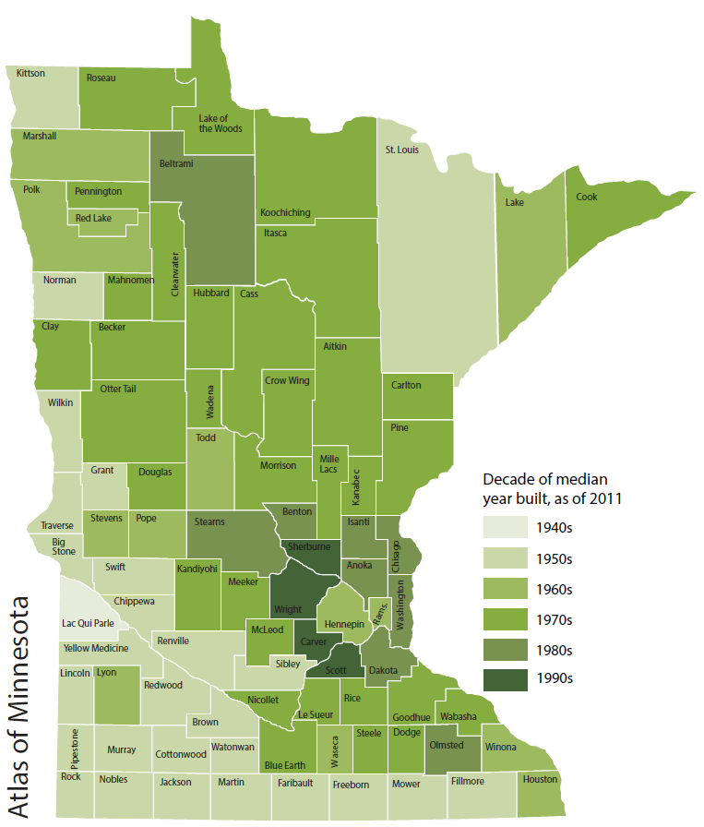
- Big Stone – 1957
- Chippewa – 1956
- Lac qui Parle – 1949
- Swift – 1959
- Yellow Medicine - 1952

References
- Wikipedia. Big Stone County, Minnesota. Retrieved from http://en.wikipedia.org/wiki/Big_Stone_County,_MN
- Wikipedia. Chippewa County, Minnesota. Retrieved from http://en.wikipedia.org/wiki/Chippewa_County,_MN
- Wikipedia. Lac qui Parle County, Minnesota. Retrieved from http://en.wikipedia.org/wiki/Lac_qui_Parle_County,_Minnesota
- Wikipedia. Swift County, Minnesota. Retrieved from http://en.wikipedia.org/wiki/Swift_County,_Minnesota
- Wikipedia. Yellow Medicine County, Minnesota. Retrieved from http://en.wikipedia.org/wiki/Yellow_Medicine_County,_MN
- Minnesota County Health Tables. Retrieved from http://www.health.state.mn.us/divs/chs/countytables/index.htm
- Bureau of Labor Statistics. Labor force data by county, 2011 annual averages. Retrieved from http://www.bls.gov/lau/tables.htm
- MN Public Health Data Access. School Free/Reduced Price Lunch (childhood poverty).Retrieved March 31,2015 from https://apps.health.state.mn.us/mndata/home
- Minnesota Vital Statistics State, County and Community Health Board Trends (VS Trends). Retrieved from http://www.health.state.mn.us/divs/chs/trends/index.html
- Wilder Research.2010 Southwest South Central Adult Health Survey. Retrieved from http://www.wilder.org
- Minnesota Student Survey. Retrieved from http://www.health.state.mn.us/divs/chs/mss/
- Center for Rural Policy and Development. Atlas Online, Health, Physicians. Retrieved August 19,2013 from www.ruralmn.org/atlas-online
- Center for Rural Policy and Development. Atlas Online, Health, Dentists. Retrieved August 19,2013 from www.ruralmn.org/atlas-online
- MN Public Health Data Access. Children Medicaid Dental/Oral Health Service Use. Retrieved March 1,2015 from https://apps.health.state.mn.us/mndata/home
- United State Environmental Protection Agency. Radon. Retrieved March 2,2015 from http://www.epa.gov/radon/states/minnesota.html
- MN Public Health Data Access. Childhood Lead Poisoning. Retrieved March 16, 2015 from https://apps.health.state.mn.us/mndata/home
- Center for Rural Policy and Development. Atlas Online, Housing, Housing Built Before 1940. Retrieved March 16,2015 from www.ruralmn.org/atlas-online
- Center for Rural Policy and Development. Atlas Online, Housing, Median Year Built. Retrieved March 16,2015 from www.ruralmn.org/atlas-online

