Performance Management Plan
Madison County Department of Health

2018

CONTENTS
Contents ..................................................................................................................................... 1
Background................................................................................................................................ 2
Culture of Quality........................................................................................................................ 2
Goals and Objectives ............................................................................................................... 3
Performance Management Plan – Overview ........................................................................ 3
Purpose...………………............................................................................................................... 4
Performance Management System ........................................................................................ 4
Performance Standards............................................................................................................. 5
Performance Measurement...................................................................................................... 5
Reporting Progress...................................................................................................................... 6
Quality Improvement................................................................................................................. 6
Self-Assessment…………............................................................................................................ 7
Roles and Responsibilities.......................................................................................................... 7
Performance Communications................................................................................................ 9
Workforce Training.................................................................................................................... 10
Sustainability of the Plan.......................................................................................................... 10
Supporting Documents............................................................................................................ 10
Definitions………………............................................................................................................. 11
Appendices………………………………………………:..............................................................14
Appendix A – Performance Management Tracking Document …………………...14
Appendix B – Self-Assessment Tool………………………………………………………...15

May 9, 2018
Background
The Performance Management Plan provides the necessary framework for the Madison County Department of Health (MCDOH) to advance a culture of quality through performance evaluation and enabling continuous quality improvement department-wide. This is performed through program level assessment, data-driven decision making, and process improvement.

In 2016, the MCDOH completed its strategic plan. National efforts to establish core public health capacities and improve delivery of local public health department services guided the planning process. These included Public Health Accreditation Board standards and measures, the Public Health Core Functions, and the Essential Public Health Services. At the state level, the NYS Prevention Agenda and Article 6 Public Health Funding performance requirements further informed the planning process.

The MCDOH management team used a self-assessment tool created by the Minnesota Department of Health to assess the department based on national public health accreditation standards. Performance management and quality improvement were identified as priority areas for improvement.

Culture of Quality
The MCDOH is taking steps to build a culture of continuous quality improvement (QI) within the department. In August 2017, a cross-divisional Quality Improvement Steering Committee was formed to develop and implement a quality improvement plan that integrated QI into all aspects of our department. The plan was approved in December 2017, with implementation of the plan starting immediately thereafter.

Basic Performance Management training was provided by the Public Health Foundation for all staff in March 2018. Between August and October 2017, a 12-person committee comprised of staff and management underwent a Quality Improvement training provided by the Ohio State University, College of Public Health’s, Center for Public Health Practice. Additional trainings on quality improvement and performance management were conducted at an individual level through the NYS Learning Management System.

In May 2018, the Public Health Foundation Turning Point Performance Management Self-Assessment was completed to evaluate MCDOH’s current capacity to manage performance. The following areas were identified as priority areas to be addressed:
- Performance standards/measures across all divisions
- Workforce development/Training
- Communications/Reporting

Goals and Objectives
The MCDOH will establish goals, objectives, and measures for both programmatic and administrative areas of operations. Annually, MCDOH Senior Management will review and revise, where appropriate, the goals and objectives of this plan. The goals, objectives, and measures for our performance management efforts for the current year are found in Appendix A of this plan.

Performance Management Plan – Overview
The MCDOH Performance Management Plan was developed to assist in achieving the goal identified within the department’s strategic plan to: evaluate and continuously improve MCDOH’s processes, programs and interventions in order to protect and promote health in Madison County. Use of this Performance Management Plan will facilitate the progress of meeting strategic aims and ensure good stewardship of resources by using measurable outcomes to determine which activities positively impact the public’s health. Furthermore, this plan addresses Domain 9 of the Public Health Accreditation Board (PHAB) Standards and Measures Version 1.5.
The Performance Management Plan will use the following model components:
1. Performance Standards
2. Performance Measures
3. Report of Progress
4. Quality Improvement
The successful implementation of this plan relies on defined roles and responsibilities of The Public Health Director and Division Managers, All-Staff, Quality Improvement Committee members, Health and Human Services Committee, and the Board of Health. This plan outlines a sustainable performance management system, which requires strong internal and external communication and workforce training, as well as an emphasis on quality improvement.

Purpose
Performance management is the practice of actively using data to improve the public's health. This involves strategic use of performance measures and standards to establish targets and goals, to prioritize and allocate resources, inform managers about needed adjustments or changes in policy or program directions to meet goals, frame reports on the success in meeting performance goals, and improve the quality of public health practice.

Performance Management System
A performance management system is the continuous use of the four components which are integrated into the department’s core operations. The MCDOH utilizes the following revised model of the Turning Point Performance Management System Framework (Figure 1).

Figure 1.
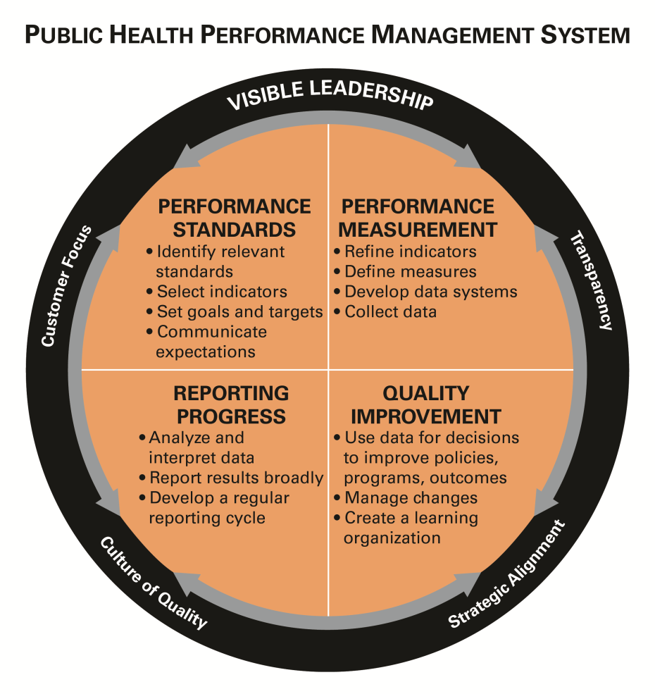

Source: Turning Point Performance Management Framework, revised 2012

Performance Standards
Performance Standards are objective guidelines that are used to assess an organization’s performance. Standards involve setting goals, targets, and expectations across the organization. The MCDOH Performance Standards are linked to the Public Health Accreditation Board standards, the department’s strategic plan, county health improvement plan, county Success Plan, and New York State Department of Health (NYSDOH) requirements.

Performance Measurement
Performance measures are the quantitative measures of capacities, processes, systems, and/or outcomes relevant to the assessment of a performance indicator. Appendix A contains current performance measures being tracked by MCDOH and its programs. New measures will be added as needed and as determined by NYSDOH requirements, Community Health Improvement plan priorities, MCDOH strategic plan priorities, quality improvement initiatives, customer and stakeholder feedback, and evaluation of performance management activities.

The results of customer satisfaction surveys and feedback from community partners and stakeholder groups, both at the programmatic and departmental level will be evaluated by the Senior Management Committee, in concert with program measures to assess overall performance. Senior Management will review customer satisfaction survey results on a quarterly basis.

Reporting Progress
The process of reporting progress is designed to keep staff informed. Designated staff will submit data on performance measures regularly to the Performance Management Tracking Document on the shared Health (P:) Drive. The Senior Management Committee will review data, including customer satisfaction survey results, on a quarterly basis or when deemed necessary. Data will be available to all staff through the Health (P:) Drive in the Performance Management folder. At monthly senior management meetings, division directors will rotate reporting on performance measures. This will allow for collaboration and problem solving at the leadership level. The Senior Management Committee will update members of the organization as described in the performance communication plan. See the Performance Management Tracking Document in Appendix A for the current listing of department’s goals, objectives, performance measures, analysis tools, and reporting periods by division.

Quality Improvement
Quality improvement (QI) in public health is the use of a deliberate and defined improvement process, such as Plan-Do-Study-Act, which is focused on activities that are responsive to community needs and improving population health. It refers to a continuous and ongoing effort to achieve measurable improvements in the efficiency, effectiveness, performance, accountability, outcomes, and other indicators of quality in services or processes which achieve equity and improve the health of the community (Riley, 2010).

The MCDOH approved its QI plan in December 2017. The Plan uses the Plan-Do-Study-Act (PDSA) framework. The purpose of the plan is to guide the development, implementation, monitoring, and evaluation of cross-divisional efforts to build a culture of continuous quality improvement throughout the department. The QI plan will guide QI activities within the department and be used to inform the overall department Performance Management System. The QI plan is located on the shared (P:) drive at P:\Quality Improvement\QI Plan.

The Quality Improvement Committee comprised of both management and non-management staff meets monthly to review QI initiatives and activities. Quarterly, the QI Committee will provide a progress report to the Senior Management Committee.

Self-assessment
Self-assessment is a critical component of successful implementation of the department’s performance management system. Annually, a joint Senior Management Committee/QI Committee team will conduct an assessment of the department’s performance management system using the Performance Management Self-Assessment Tool available on the Public Health Foundation web site at http://www.phf.org/focusareas/performancemanagement/toolkit/Pages/PM_Toolkit_Self_Assessment.aspx A copy of the assessment tool is in Appendix B.

Roles and Responsibilities
All MCDOH staff, from front line staff to supervisors, and department leadership will participate in developing, using, and updating the performance management plan. The following contains specific roles and responsibilities for key groups within the department:
Board of Supervisors/Board of Health/County Administrator
- Identify public health services in need of quality improvement of focus
- Provide feedback for completed and ongoing projects
- Review and approve resource needs for PM activities and initiatives

Public Health Director
- Provide leadership and direction for performance management and quality improvement efforts;
- Promote a culture of quality within the department;
- Provide oversight and accountability;
- Facilitate the implementation of projects in other areas of the department, as needed;
- Provide access to resources and trainings, as appropriate.
- Be apprised of all current projects;
- Allow time at all staff meetings to discuss ongoing and completed projects;
- Approve performance management activities.
- Share department’s performance management system and QI activities with Board of Supervisors and Board of Health members.
Division Directors and Supervisors
- Ensure performance measure accuracy;
- Promote a culture of quality within the department;
- Support QI efforts of the department;
- Assure staff participation in QI training and projects;
- Encourage and allow staff time to participate in quality improvement projects; and
- Identify appropriate PM/QI training and resources for staff.
Senior Management Committee (Department and Division Directors)
- Serve as the Performance Management Committee (PMC) for the department;
- Provide leadership and direction for performance management and QI efforts;
- Monitor department’s performance management activities through use of Performance Management Tracking Document and customer satisfaction surveys;
- Ensure the work of the PMC complies with PHAB accreditation standards;
- Make recommendations for improvement based on strategic plan priorities, performance management data, customer feedback, employee suggestions, and other relevant data;
- Develop and implement performance communication plan;
- Review QI reports and provide guidance and direction to QI committee; and
- Review and approve new performance measures.
Quality Improvement Committee (a.k.a., Staff/Management Committee)
- Champion QI efforts throughout department;
- Assess agency-wide QI efforts (annually);
- Review, revise, and approve QI Plan (annually);
- Evaluate and prioritize project ideas;
- Monitor QI projects, act to solve problems, and support implementation of quality improvements system-wide;
- Assure adequate resources are devoted to QI initiatives;
- Develop and implement a QI communication plan;
- Ensure MCDOH QI efforts, success, and lessons learned are shared among staff;
- Recognize individual staff’s outstanding contribution(s) to QI; and
- Provide progress report on QI activities to the Senior Management Committee on a quarterly basis.
Division Programs (All-Staff)
- Participate in QI training provided;
- Apply QI principles and tools to daily work;
- Discuss and develop QI opportunities;
- Implement and evaluate projects; and
- Over time become engaged in QI opportunities (includes suggesting ideas, providing feedback to their QI Committee representative, participating in projects and encouraging other staff to participate).

Performance Communications
The Senior Management Committee is responsible for developing and implementing a communication plan to ensure that all staff and county leadership are kept apprised of performance management and quality improvement activities.

Workforce Training
Annually the Professional Development Committee will conduct a workforce development assessment using, in part, the Core Competencies for Public Health Professionals. Results of the annual assessment will be used to develop and guide the implementation of staff training activities and building organizational capacity. These training needs should align with the department’s workforce development plan.
Annually, the Professional Development Committee will provide the Senior Management Committee with a progress report on staff training activities.

Sustainability of the Plan
The Senior Management Committee will review and recommend necessary updates of the performance management plan on an annual basis. Updates on the plan’s progress will be provided on a quarterly basis to the Quality Improvement Committee and discussed at division staff meetings.

Supporting Documents
- Madison County Department of Health, Strategic Plan Final Report: https://www.madisoncounty.ny.gov/Archive.aspx?AMID=54
- Madison County Department of Health, Workforce Development Plan Final Report: Available on the Public Health (P:) Drive - P:\Strategic Plan 2015\Career development.
- Madison County Department of Health, Quality Improvement Plan final Report: Available on the Public Health P:) drive at P:\Quality Improvement\QI Plan.
- Madison County Community Health Improvement Plan report: https://www.madisoncounty.ny.gov/Archive.aspx?AMID=53
- New York State Department of Health, Office of Public Health Practice. Local Health Department Performance Incentive Initiative. P:/Performance Management/NYSDOH Performance Incentive.
- Madison County Success Plan report: P:/Performance Management/County Success Plan
- Madison County Health Department PM Communication Plan report: P:/Performance Management/Communication Plan.
- New York State Prevention Agenda: https://www.health.ny.gov/prevention/prevention_agenda/2013-2017/
- Public Health Accreditation Board, Standards and Measures for Initial Accreditation. http://www.phaboard.org/accreditation-process/public-health-department-standards-and-measures/

Definitions
Data
Data are factual information (as measurements or statistics) used as a basis for reasoning, discussion, or calculation. Information in numerical form that can be digitally transmitted or processed. (http://www.merriam-webster.com/dictionary/data).

Evidence-based Practice
Evidenced-based practice involves making decisions on the basis of the best available scientific evidence, using data and information systems systematically, applying program-planning frameworks, engaging the community in decision making, conducting sound evaluation, and disseminating what is learned. (Brownson, Fielding and Maylahn. Evidence-based Public Health: A Fundamental Concept for Public Health Practice. Annual Review of Public Health).

Goals
Goals are general statements expressing a program's aspirations or intended effect on one or more health problems, often stated without time limits. (Turnock, B.J. Public Health: What It Is and How It Works. 4th ed. Sudbury, MA: Jones and Bartlett; 2009.)

Objectives
Objectives are targets for achievement through interventions. Objectives are time limited and measurable in all cases. Various levels of objectives for an intervention include outcome, impact, and process objectives. (Turnock, B.J. Public
Health: What It Is and How It Works. 4th ed. Sudbury, MA: Jones and Bartlett; 2009.)

PDSA (Plan-Do-Study-Act)
PDSA is an iterative four-stage problem-solving model for improving a process or carrying out change. PDSA stems from the scientific method (hypothesize, experiment, evaluate). A fundamental principle of PDSA is iteration. Once a hypothesis is supported or negated, executing the cycle again will extend what one has learned. (Embracing Quality in Local Public Health, Michigan’s QI Guidebook)

Performance Management
Performance Management is a systematic process which helps an organization achieve its mission and strategic goals by improving effectiveness, empowering employees, and streamlining decision making. In practice, performance management often means actively using data to improve performance, including the strategic use of performance standards, measures, progress reports, and ongoing quality improvement efforts to ensure an agency achieves desired results. http://www.phf.org/focusareas/performancemanagement/Pages/Performance_Management.aspx Accessed 4/27/18.

Public Health Accreditation Board (PHAB)
The Public Health Accreditation Board is the national accrediting organization for public health departments. A nonprofit organization, PHAB is dedicated to advancing the continuous quality improvement of Tribal, state, local, and territorial public health departments. PHAB is working to promote and protect the health of the public by advancing the quality and performance of all public health departments in the United States through national public health department accreditation.(Public Health Accreditation Board. Guide to National Public Health Department Accreditation Version 1.0. Alexandria, VA, May 2011)

Quality Improvement (QI)
Quality improvement in public health is the use of a deliberate and defined improvement process, such as Plan-Do-Check-Act, which is focused on activities that are responsive to community needs and improving population health. It refers to a continuous and ongoing effort to achieve measurable improvements in the efficiency, effectiveness, performance, accountability, outcomes, and other indicators of quality in services or processes which achieve equity and improve the health of the community. (Riley, Moran, Corso, Beitsch, Bialek, and Cofsky. Defining Quality Improvement in Public Health. Journal of Public Health Management and Practice. January/February 2010).

Appendix A

Appendix B

